

AP® Physics C
1977 Free Response Questions

The materials included in these files are intended for use by AP teachers for course and exam preparation in the classroom; permission for any other use must be sought from the Advanced Placement Program®. Teachers may reproduce them, in whole or in part, in limited quantities, for face-to-face teaching purposes but may not mass distribute the materials, electronically or otherwise. These materials and any copies made of them may not be resold, and the copyright notices must be retained as they appear here. This permission does not apply to any third-party copyrights contained herein.

These materials were produced by Educational Testing Service® (ETS®), which develops and administers the examinations of the Advanced Placement
Program for the College Board. The College Board and Educational Testing Service (ETS) are dedicated to the principle of equal opportunity, and their
programs, services, and employment policies are guided by that principle.

The College Board is a national nonprofit membership association dedicated to preparing, inspiring, and connecting students to college and opportunity.
Founded in 1900, the association is composed of more than 4,200 schools, colleges, universities, and other educational organizations. Each year, the
College Board serves over three million students and their parents, 22,000 high schools, and 3,500 colleges, through major programs and services in
college admission, guidance, assessment, financial aid, enrollment, and teaching and learning. Among its best-known programs are the SAT®, the
PSAT/NMSQT®, and the Advanced Placement Program® (AP®). The College Board is committed to the principles of equity and
excellence, and that commitment is embodied in all of its programs, services, activities, and concerns.

APIEL is a trademark owned by the College Entrance Examination Board. PSAT/NMSQT is a registered trademark jointly owned by the College Entrance Examination Board and the National Merit Scholarship Corporation. Educational Testing Service and ETS are registered trademarks of Educational Testing Service.
1977M1. A block of mass m, which has an initial velocity v_{o} at time t = 0, slides on a horizontal surface.
a. How much work must be done on the block to bring it to rest?
If the sliding friction force f exerted on the block by the surface is directly proportional to its velocity (that is, f = -Kv) determine the following:
b. The acceleration a of the block in terms of m, k, and v.
c. The speed v of the block as a function of time t.
d. The total distance the block slides.

1977M2. A uniform cylinder of mass M, and radius R is initially at rest on a rough horizontal surface. The moment of inertia of a cylinder about its axis is ½MR². A string, which is wrapped around the cylinder, is pulled upwards with a force T whose magnitude is 0.6Mg and whose direction is maintained vertically upward at all times. In consequence, the cylinder both accelerates horizontally and slips. The coefficient of kinetic friction is 0.5.
a. On the diagram below, draw vectors that represent each of the forces acting on the cylinder identify and clearly label each force.
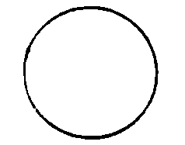
b. Determine the linear acceleration a of the center of the cylinder.
c. Calculate the angular acceleration α of the cylinder.
d. Your results should show that a and αR are not equal. Explain.

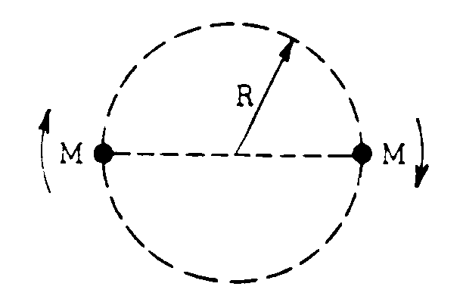
1977M3. Two stars each of mass M form a binary star system such that both stars move in the same circular orbit of radius R. The universal gravitational constant is G.
a. Use Newton's laws of motion and gravitation to find an expression for the speed v of either star in terms of R, G, and M.
b. Express the total energy E of the binary star system in terms of R, G, and M.

Suppose instead, one of the stars had a mass 2M.
c. On the following diagram, show circular orbits for this star system.

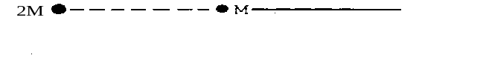
d. Find the ratio othe speeds, v_{2M}/v_{M.}

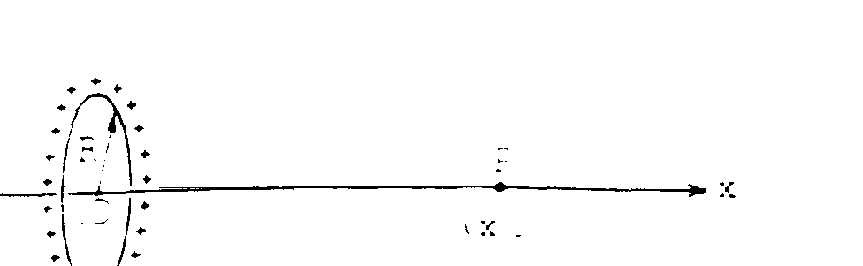
1977E1. A charge +Q is uniformly distributed around a wire ring of radius R. Assume that the electric potential is zero at x = infinity, with the origin 0 of the x-axis at the center of the ring.
a. What is the electric potential at a point P on the x-axis?
b. Where along the x-axis is the electric potential the greatest? Justify your answer.
c. What is the magnitude and direction of the electric field E at point P?
d. On the axes below, make a sketch of E as a function of the distance along the x-axis showing significant features.
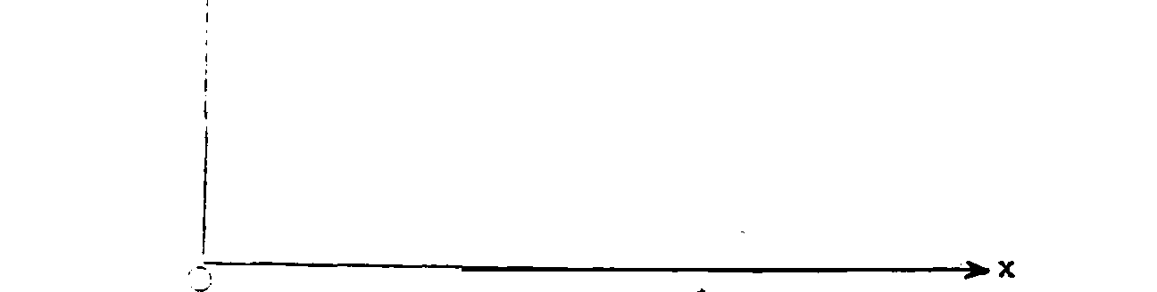

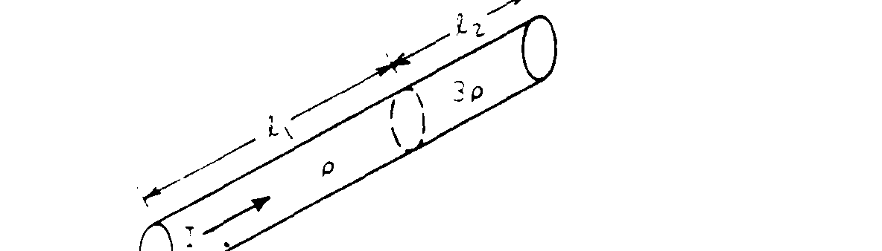
1977E2. A resistor is made in the form of a cylinder of cross-sectional area A. One portion, of
length l₁ is made of material whose resistivity is ρ, the other of length l₂ is made of material whose resistivity is 3ρ. There is a current I uniformly distributed over the area A. Express all answers in terms of fundamental constants and the symbols shown in the diagram above.
a. Determine expressions for the electric field strengths E₁ and E₂ in the two portions of the resistor.
b. Determine the potential difference V between the opposite ends of the resistor.
c. By applying Gauss's law to a surface which encloses the boundary between the two materials, determine the sign and magnitude of the electric charge which is present on this boundary.

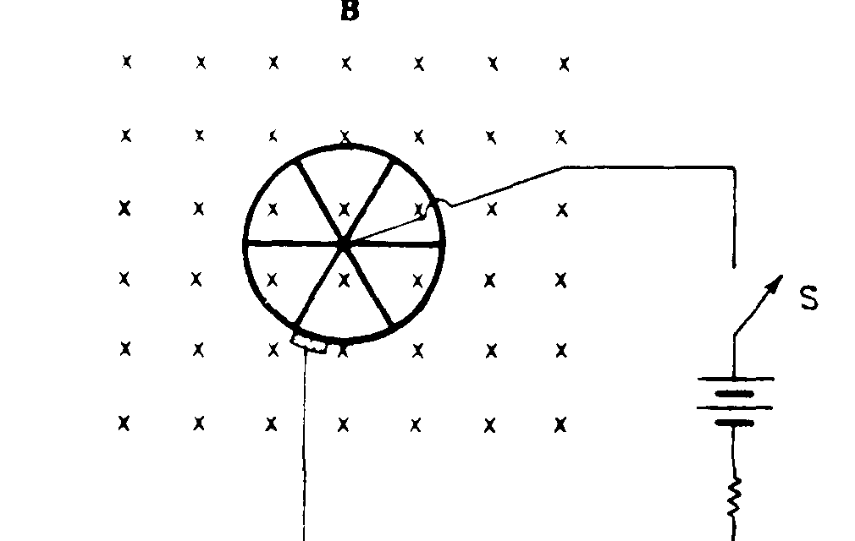
1977E3. A wheel with six spokes is positioned perpendicular to a uniform magnetic field B of magnitude 0.5 tesla (weber per square meter). The field is directed into the plane of the paper and is present over the entire region of the wheel as shown above. When the switch S is closed, there is an initial current of 6 amperes between the axle and the rim, and the wheel begins to rotate. The resistance of the spokes and the rim may be neglected.
a. What is the direction of rotation of the wheel? Explain.
b. The radius of the wheel is 0.2 meters. Calculate the initial torque on the wheel.
c. Describe qualitatively the angular velocity of the wheel as a function of time.

